**Lab 3 (Task B)**

VHDL Code

**RAM behavior Code**

**library** IEEE**;**

**use** IEEE**.**STD_LOGIC_1164**.ALL;**

**use** IEEE**.**NUMERIC_STD**.ALL;**

-- Synchronous write / asynchrounous read 32x16 single-port RAM

**entity** RAM **is**

**Port** **(** clk **:** **in** STD_LOGIC**;**

write_en **:** **in** STD_LOGIC**;** -- Write enable

Data_In **:** **in** UNSIGNED **(**15 **downto** 0**);** -- 16-bit data input

Address **:** **in** UNSIGNED **(**4 **downto** 0**);** -- 5-bit address

Data_Out **:** **out** UNSIGNED **(**15 **downto** 0**));** -- 16-bit data output

**end** RAM**;**

**architecture** Behavioral **of** RAM **is**

**type** ram_type **is** **array** **(**0 **to** 31**)** **of** UNSIGNED**(**15 **downto** 0**);**

**signal** ram_inst**:** ram_type**;**

**begin**

-- Asynchronous read

Data_Out **<=** ram_inst**(to_integer(**Address**));**

-- Synchronous write (write enable signal)

**process** **(**clk**)**

**begin**

**if** **(rising_edge(**clk**))** **then**

**if** **(**write_en**=**'1'**)** **then**

ram_inst**(to_integer(**Address**))** **<=** Data_In**;**

**end** **if;**

**end** **if;**

**end** **process;**

**end** Behavioral**;**

**Control Behaviour**

**library** IEEE**;**

**use** IEEE**.**STD_LOGIC_1164**.ALL;**

**use** IEEE**.**NUMERIC_STD**.ALL;**

**entity** Control **is**

**Port** **(** clk **:** **in** STD_LOGIC**;**

rst **:** **in** STD_LOGIC**;**

nxt **:** **in** STD_LOGIC**;**

mem_wr **:** **out** STD_LOGIC**;**

Mem_Addr **:** **out** UNSIGNED **(**4 **downto** 0**);**

r1_en **:** **out** STD_LOGIC**;**

r2_en **:** **out** STD_LOGIC**;**

out_en **:** **out** STD_LOGIC**;**

Mux_Sel **:** **out** STD_LOGIC_VECTOR **(**1 **downto** 0**));**

**end** Control**;**

**architecture** Behavioral **of** Control **is**

**type** fsm_states **is** **(**STORE_0**,** STORE_1**,** LOAD_R1**,** LOAD_R2**,** STORE_N**,** WAIT_S**);**

**signal** state**:** fsm_states**;**

**signal** next_state**:** fsm_states**;**

**signal** done **:** STD_LOGIC**;**

**signal** cnt_en **:** STD_LOGIC**;**

**signal** count **:** UNSIGNED**(**4 **downto** 0**);**

**begin**

counter**:** **process** **(**clk**)** **is**

**begin**

**if** **rising_edge(**clk**)** **then**

**if** rst **=** '1' **then**

count **<=** "00000"**;**

**else**

**if** cnt_en **=** '1' **then**

count **<=** count **+**1**;**

**end** **if;**

**end** **if;**

**end** **if;**

**end** **process** counter**;**

state_reg **:** **process** **(**clk**)** **is**

**begin**

**if** **rising_edge(**clk**)** **then**

**if** **(**rst **=** '1'**)** **then**

state **<=** STORE_0**;**

**else**

state **<=** next_state**;**

**end** **if;**

**end** **if;**

**end** **process** state_reg**;**

next_states**:** **process(**state**,**rst**,**nxt**,**done**)** **is**

**begin**

**case** state **is**

**when** STORE_0 **=>**

**if** nxt **=** '1' **then**

next_state **<=** STORE_1**;**

**else**

next_state **<=** state**;**

**end** **if;**

**when** STORE_1 **=>**

**if** nxt **=** '1' **then**

next_state **<=** LOAD_R1**;**

**else**

next_state **<=** state**;**

**end** **if;**

**when** LOAD_R1 **=>**

next_state **<=** LOAD_R2**;**

**when** LOAD_R2 **=>**

next_state **<=** STORE_N**;**

**when** STORE_N **=>**

next_state **<=** WAIT_S**;**

**when** WAIT_S **=>**

**if** nxt **=**'1' and done **=** '0' **then**

next_state **<=** LOAD_R1**;**

**else**

next_state **<=** state**;**

**end** **if;**

**when** **others** **=>**

next_state **<=** state**;**

**end** **case;**

**end** **process** next_states**;**

done **<=** '1' **when** **(**count **=** "11000"**)** **else** '0'**;**

cnt_en **<=** nxt **when** **(**state **=** STORE_0**)** or **(**state **=** STORE_1**)**

**else** **(**nxt and **(**not done**))** **when** state **=** WAIT_S

**else** '0'**;**

mem_wr **<=** '1' **when** **(**state **=** STORE_0**)**

or **(**state **=** STORE_1**)**

or **(**state **=** STORE_N**)**

**else** '0'**;**

Mem_Addr **<=** count **when** **(**state **=** STORE_0**)**

or **(**state **=** STORE_1**)**

or **(**state **=** STORE_N**)**

**else** **(**count **-** 1**)** **when** **(**state **=** LOAD_R2**)**

**else** **(**count **-** 2**)** **when** **(**state **=** LOAD_R1**)**

**else** "00000"**;**

r1_en **<=** '1' **when** **(**state **=** LOAD_R1**)**

**else** '0'**;**

r2_en **<=** '1' **when** **(**state **=** LOAD_R2**)**

**else** '0'**;**

out_en **<=** '1' **when** **(**state **=** STORE_0**)**

or **(**state **=** STORE_1**)**

or **(**state **=** STORE_N**)**

**else** '0'**;**

Mux_Sel **<=** "10" **when** **(**state **=** STORE_0**)**

**else** "11" **when** **(**state **=** STORE_1**)**

**else** "00" **when** **(**state **=** STORE_N**)**

**else** "00"**;**

**end** Behavioral**;**

VHDL Testbench Code

**LIBRARY** ieee**;**

**USE** ieee**.**std_logic_1164**.ALL;**

**USE** ieee**.**numeric_std**.ALL;**

**ENTITY** Fibonacci_tb **IS**

**END** Fibonacci_tb**;**

**ARCHITECTURE** behavior **OF** Fibonacci_tb **IS**

-- Component Declaration for the Unit Under Test (UUT)

**COMPONENT** Fibonacci

**PORT(**

clk **:** **IN** std_logic**;**

rst **:** **IN** std_logic**;**

nxt **:** **IN** std_logic**;**

Fib_Out **:** **OUT** std_logic_vector**(**15 **downto** 0**)**

**);**

**END** **COMPONENT;**

--Inputs

**signal** clk **:** std_logic **:=** '0'**;**

**signal** rst **:** std_logic **:=** '0'**;**

**signal** nxt **:** std_logic **:=** '0'**;**

--Outputs

**signal** Fib_Out **:** std_logic_vector**(**15 **downto** 0**);**

-- Clock period definitions

**constant** clk_period **:** time **:=** 10 ns**;**

**BEGIN**

-- Instantiate the Unit Under Test (UUT)

uut**:** Fibonacci **PORT** **MAP** **(**

clk **=>** clk**,**

rst **=>** rst**,**

nxt **=>** nxt**,**

Fib_Out **=>** Fib_Out

**);**

-- Clock process definitions

clk_process **:process**

**begin**

clk **<=** '0'**;**

**wait** **for** clk_period**/**2**;**

clk **<=** '1'**;**

**wait** **for** clk_period**/**2**;**

**end** **process;**

-- Stimulus process

stim_proc**:** **process**

**begin**

-- hold reset state for 100 ns.

**wait** **for** 100 ns**;**

nxt **<=** '0'**;**

rst **<=** '1'**;**

**wait** **for** clk_period**\***2**;**

next_loop**:** **LOOP** --loop for next button to toggle with 3 clock periods

nxt **<=** '1'**;**

**wait** **for** clk_period**\***3**;**

nxt **<=** '0'**;**

**wait** **for** clk_period**\***3**;**

**END** **LOOP** next_loop**;**

**wait;**

**end** **process;**

**END;**

Simulation

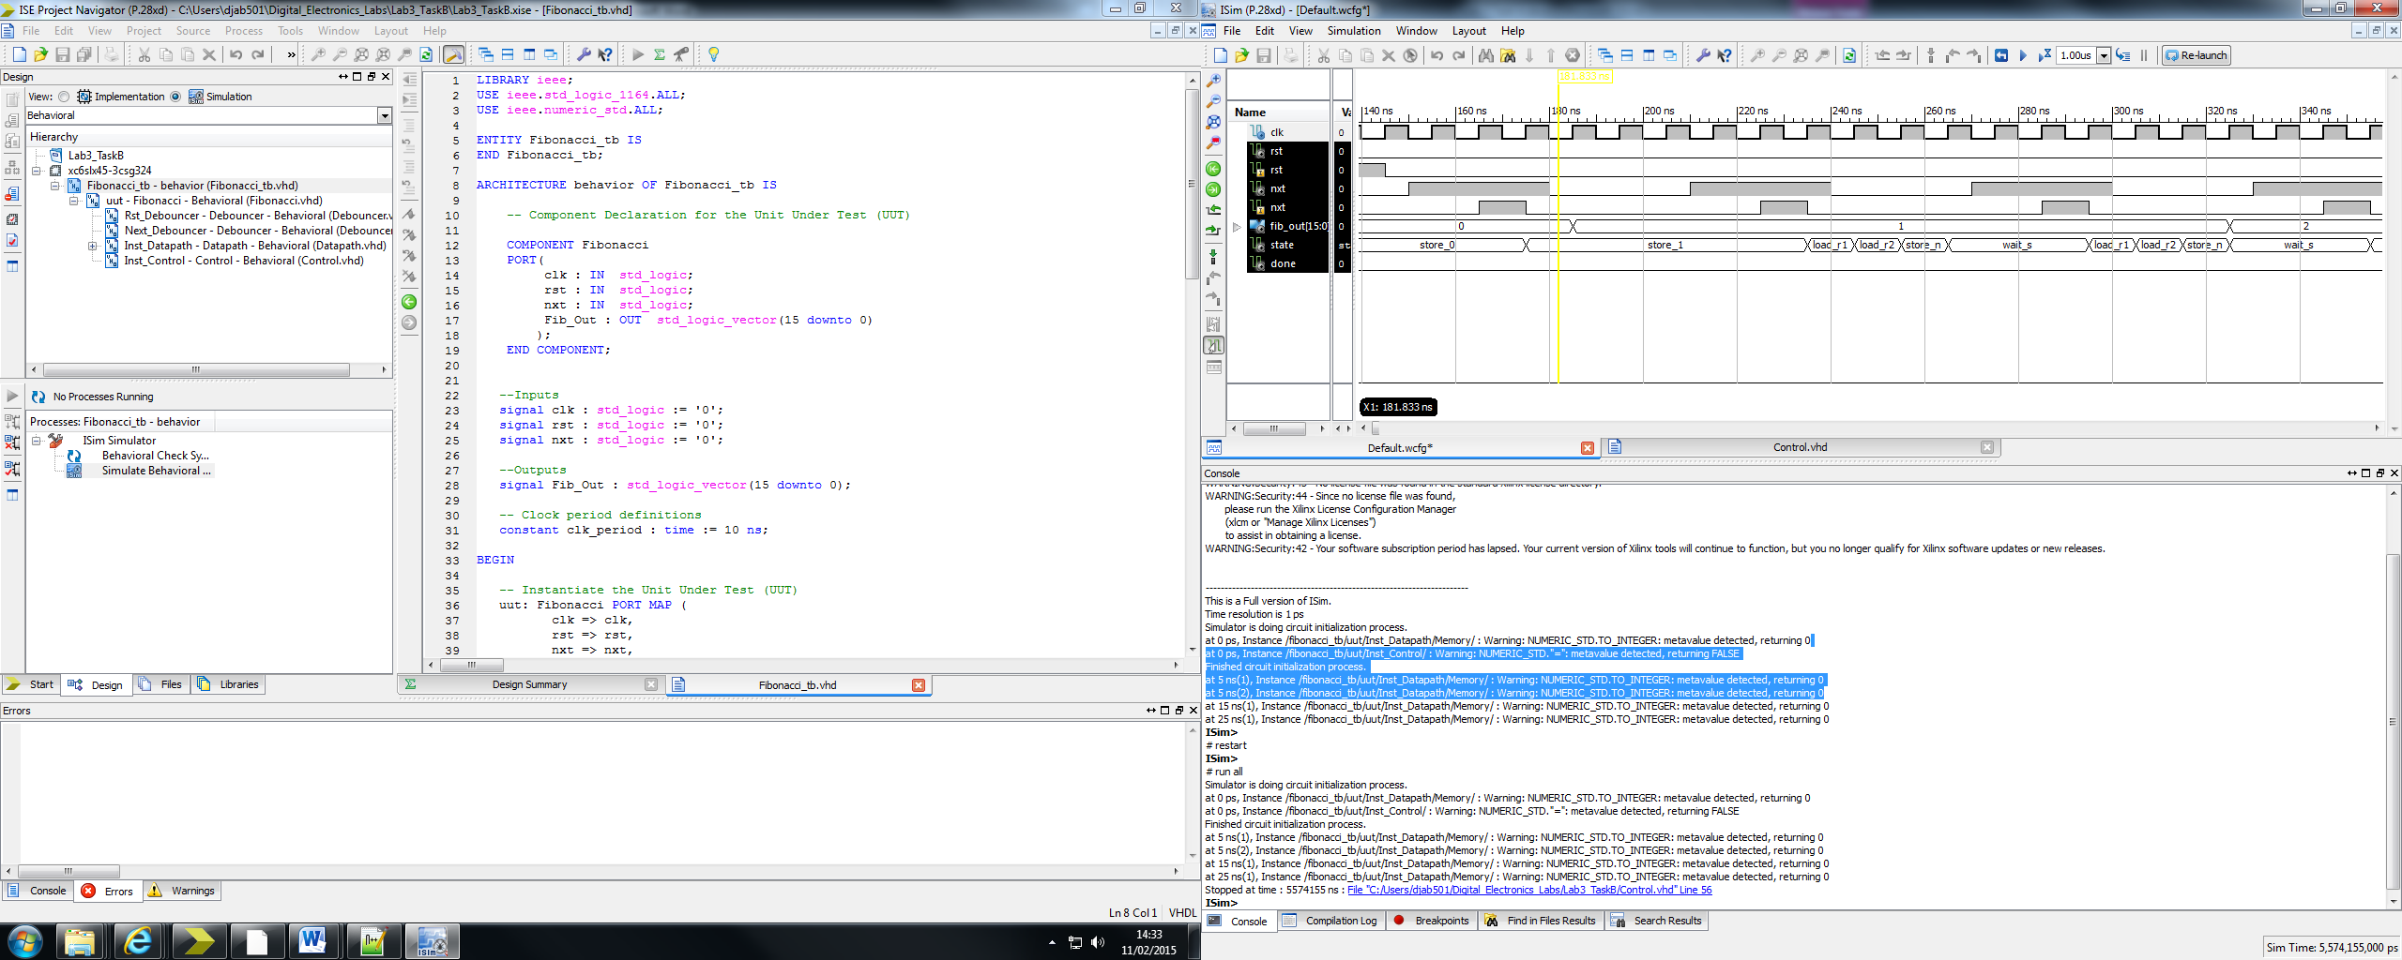

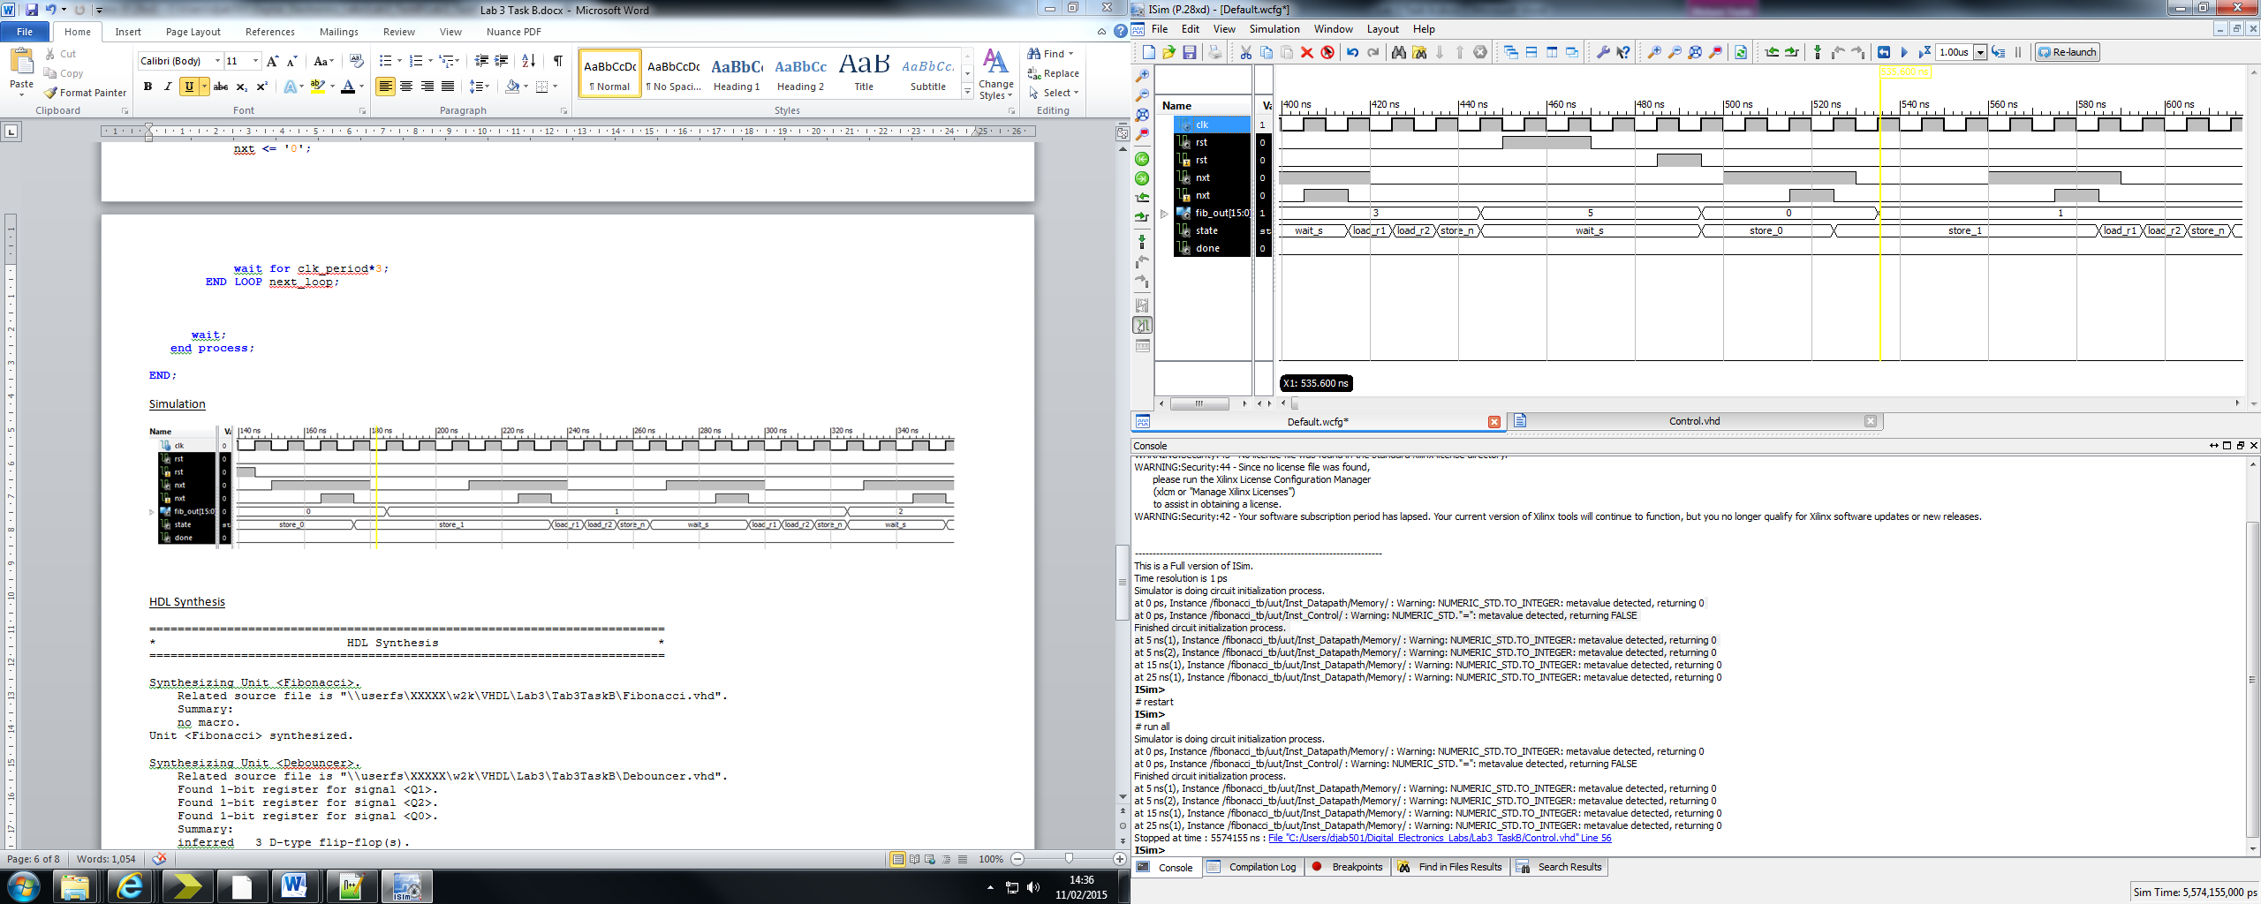

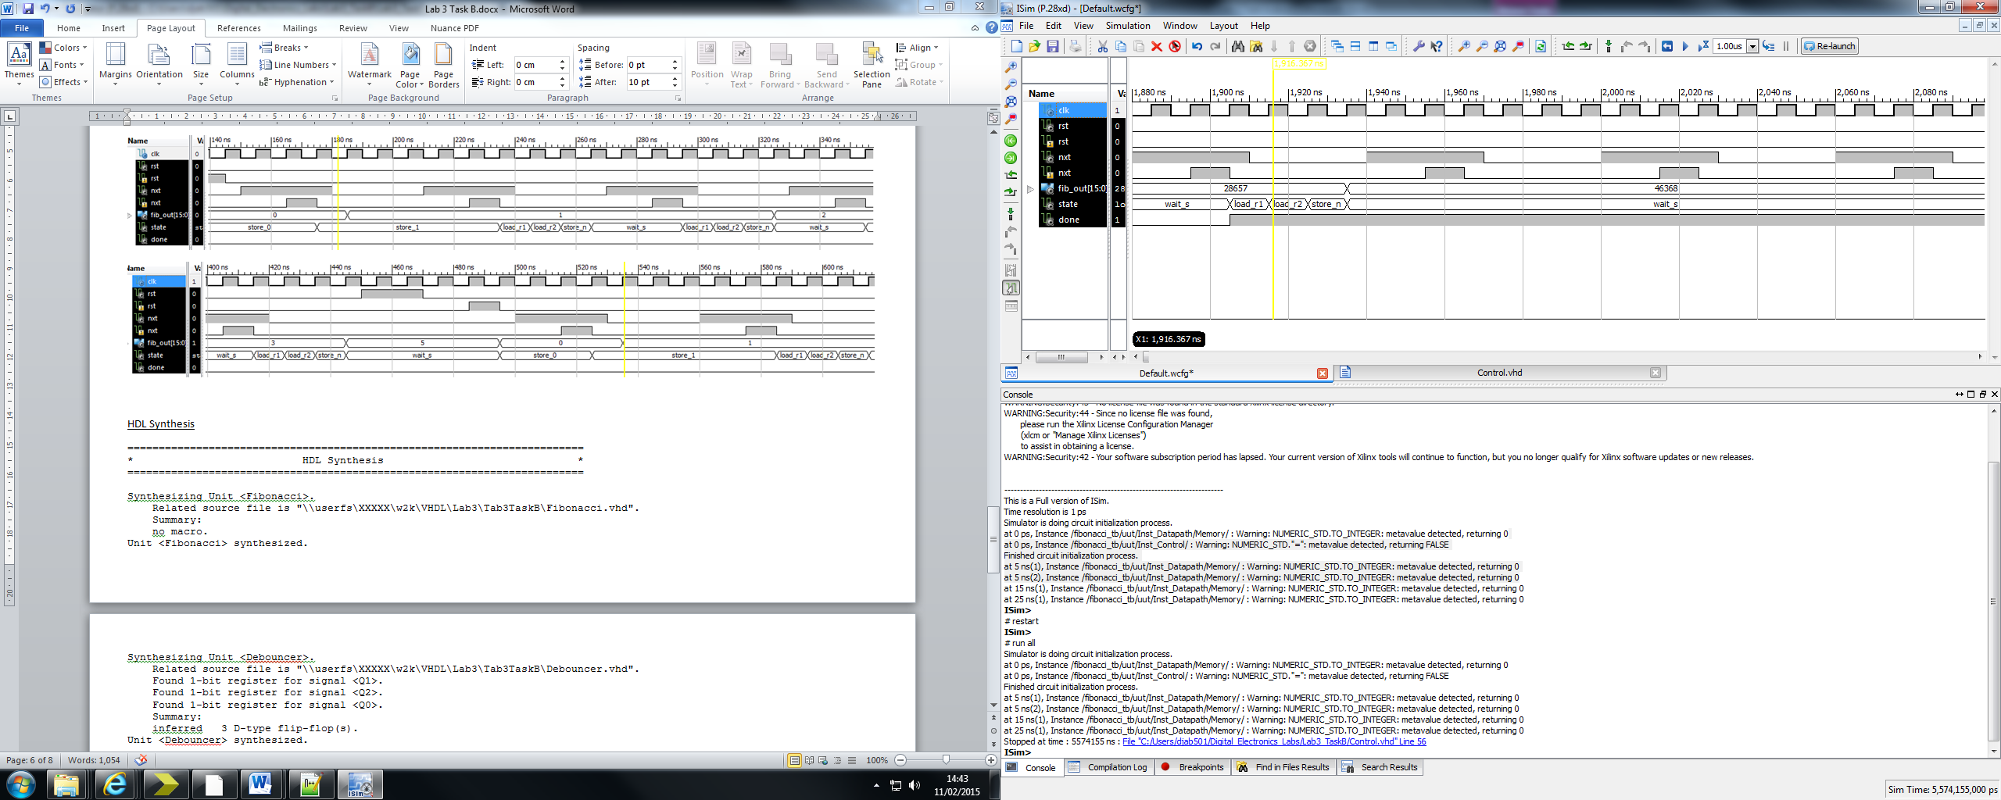

HDL Synthesis

=========================================================================

* HDL Synthesis *

=========================================================================

Synthesizing Unit <Fibonacci>.

Related source file is "\\userfs\XXXXX\w2k\VHDL\Lab3\Tab3TaskB\Fibonacci.vhd".

Summary:

no macro.

Unit <Fibonacci> synthesized.

Synthesizing Unit <Debouncer>.

Related source file is "\\userfs\XXXXX\w2k\VHDL\Lab3\Tab3TaskB\Debouncer.vhd".

Found 1-bit register for signal <Q1>.

Found 1-bit register for signal <Q2>.

Found 1-bit register for signal <Q0>.

Summary:

inferred 3 D-type flip-flop(s).

Unit <Debouncer> synthesized.

Synthesizing Unit <Datapath>.

Related source file is "\\userfs\XXXXX\w2k\VHDL\Lab3\Tab3TaskB\Datapath.vhd".

Found 16-bit register for signal <R2_Out>.

Found 16-bit register for signal <Fib_Out>.

Found 16-bit register for signal <R1_Out>.

Found 16-bit adder for signal <R1_Out[15]_R2_Out[15]_add_3_OUT> created at line 32.

Summary:

inferred 1 Adder/Subtractor(s).

inferred 48 D-type flip-flop(s).

Unit <Datapath> synthesized.

Synthesizing Unit <RAM>.

Related source file is "\\userfs\XXXXX\w2k\VHDL\Lab3\Tab3TaskB\RAM.vhd".

Found 32x16-bit single-port RAM <Mram_ram_inst> for signal <ram_inst>.

Summary:

inferred 1 RAM(s).

Unit <RAM> synthesized.

Synthesizing Unit <Control>.

Related source file is "\\userfs\XXXXX\w2k\VHDL\Lab3\Tab3TaskB\Control.vhd".

Found 3-bit register for signal <state>.

Found 5-bit register for signal <count>.

Found finite state machine <FSM_0> for signal <state>.

-----------------------------------------------------------------------

| States | 6 |

| Transitions | 10 |

| Inputs | 2 |

| Outputs | 11 |

| Clock | clk (rising_edge) |

| Reset | rst (positive) |

| Reset type | synchronous |

| Reset State | store_0 |

| Power Up State | store_0 |

| Encoding | auto |

| Implementation | LUT |

-----------------------------------------------------------------------

Found 5-bit adder for signal <count[4]_GND_10_o_add_0_OUT> created at line 1241.

Found 5-bit subtractor for signal <GND_10_o_GND_10_o_sub_23_OUT<4:0>> created at line 1308.

Found 5-bit subtractor for signal <GND_10_o_GND_10_o_sub_25_OUT<4:0>> created at line 1308.

Found 5-bit 3-to-1 multiplexer for signal <_n0053> created at line 100.

Summary:

inferred 2 Adder/Subtractor(s).

inferred 5 D-type flip-flop(s).

inferred 6 Multiplexer(s).

inferred 1 Finite State Machine(s).

Unit <Control> synthesized.

=========================================================================

HDL Synthesis Report

Macro Statistics

# RAMs : 1

32x16-bit single-port RAM : 1

# Adders/Subtractors : 3

16-bit adder : 1

5-bit adder : 1

5-bit subtractor : 1

# Registers : 10

1-bit register : 6

16-bit register : 3

5-bit register : 1

# Multiplexers : 6

1-bit 2-to-1 multiplexer : 2

2-bit 2-to-1 multiplexer : 1

5-bit 2-to-1 multiplexer : 3

# FSMs : 1